({[M838]} PLS-CLIENT-ID = {[PLSID]} Produce)
{[CompanyLongName]}
{[CorporateAddr1]}
{[CorporateAddr2]}

{[L001E8]} (System Date)

{[M558]} (New Bill Line 1/Mortgagor Name)
{[M559]} (New Bill Line 2/Second Mortgagor)
{[M560]} (New Bill Line 3/Third Mortgagor)
{[M561]} (Additional Mailing Address)
{[M562]} (Mailing Street Address)
{[M563]} {[M564]} {[M565]} {[M566]} (Mailing City), (State), (5-Digit Zip), (4-Digit Zip)
(“OR” If {[M956]} (Foreign Address Indicator) = Y)
{[M928]} (Foreign Country Code)
{[M929]} (Foreign Postal Code)

see “SII Confirmed” on Letter Library Business Rules for Additional Addresses in BKFS)
Non-borrower Name
Non-borrower Address Line 1
Non-borrower Address Line 2
Non-borrower Address Line 3
Non-borrower Street

SUBJECT: Special FEMA Forbearance Plan
LOAN NUMBER: {[M594]} (Loan Number – No Dash)
PROPERTY ADDRESS: {[M567]} (New Property Line 1/Street Address)
{[M583]} (New Property Unit Number)
{[M568]} (New Property Line 2/City State and Zip Code)

Dear {[M558]} (Mortgagor Name) and {[M559]} (Second Mortgagor),

(or if {[H202]} present)
Dear {[H202]},

(or if {[H223]} present)
Dear {[H223]},

(or if {[H244]} present)
Dear {[H244]},

(or if {[H265]} present)
Dear {[H265]},

(or if {[H372]} present)
Dear {[H372]},

(or if {[H393]} present)
Dear {[H393]},

(or if {[H503]} present)
Dear {[H503]},

(or if {[H524]} present)
Dear {[H524]},

Thank you for contacting us about your mortgage. Based on careful review of the information you provided, we are offering you an opportunity to enter into a forbearance plan. It is important that you read all the information in this letter so that you understand the actions you must take to complete this forbearance plan and any additional steps you must take to resolve your delinquency.

What is a Forbearance Plan?
A forbearance plan is an agreement that allows borrowers experiencing a temporary hardship to make a reduced mortgage payment or no mortgage payment during the plan’s term.
Under this forbearance plan, If {[M944]} =”H”, then print, else suppress we have suspended your monthly mortgage payment obligation, as more fully described below, for {[Q177]} (Plan Count) months. If {[M944]} =”F”, then print, else suppress you may make the reduced payments in the table below in lieu of your regular mortgage payment for {[Q177]} (Plan Count) months.
{[Q189]} (All Promises)

We will not pursue foreclosure during the forbearance plan term. However, the terms of your mortgage remain unchanged. By not making reduced payments during the plan’s term, you will become more delinquent and your credit score may be impacted. For more information refer to the Additional Forbearance Plan Information and Legal Notices.

We hope this will provide you with the time and flexibility you need to address your hardship and improve your financial position.

QUESTIONS? CONTACT US

{[CompanyLongName]}
Phone: {[CSPhoneNumber]}
Email Address: {[LossMitEmail]}
Website: {[WebSite]}

ACT NOW!

To Prevent Foreclosure Action
You must do one of the following by {[L001E7]} (Today’s Date) + 14 Days):
- Contact us by phone or in writing to let us know that you intend accept this offer, OR
- Accept this offer by sending us your first reduced payment amount.

If you do not contact us or send a payment by the above deadline, we may refer your loan to foreclosure.

To Accept This Offer
You must send your first reduced payment amount noted above on or before {[Q179E7]} (First Payment Promise Date).

If you do not send your first temporarily reduced mortgage payment by the last day of the month in which it is due, this offer is revoked at that time and we may refer your mortgage to foreclosure, or, if applicable, continue foreclosure proceedings, and a foreclosure sale may occur.

Next Steps If You Accept This Offer
- Continue making your temporarily reduced mortgage payment on time.
- Contact us immediately if your financial circumstances change during the term of your forbearance plan so that we may discuss potential options to resolve your delinquency.
- Prior to the end of the forbearance plan, we will contact you to discuss your situation and provide information on options that may be available to you. Options to resolve your delinquency may include a reinstatement, repayment plan, or loan modification. If you are unable to resolve your delinquency, there may be options that allow you to leave your home while avoiding foreclosure.

Additional Forbearance Plan Information and Legal Notices
Legal Notice Forbearance Plan Information and Legal Notices
Credit Reporting:
- We will continue to report the delinquency status of your mortgage as well as your entry into a forbearance plan to credit reporting agencies in accordance with applicable law.
- CREDIT REPORTING AGENCIES GENERALLY CONSIDER THE ENTRY INTO A PLAN WITH REDUCED PAYMENTS AS AN INCREASED CREDIT RISK. HOWEVER, A FORECLOSURE WOULD HAVE A MORE NEGATIVE IMPACT TO YOUR CREDIT SCORE.
We will not refer your mortgage to foreclosure or proceed to foreclosure sale during this forbearance plan, provided you are complying with its terms:
- Any pending foreclosure action or proceeding that has been suspended may be resumed if you do not follow the terms of the forbearance plan.
- This forbearance plan offer is contingent on your having provided us with accurate and complete information. We reserve the right to revoke this offer or terminate the forbearance plan following your acceptance if we learn of information that would make you ineligible.
- We will hold the forbearance plan payments in an account until it contains sufficient funds to pay your oldest past due monthly payment. Unless required by applicable law, there will be no interest paid on the funds in the account. If any funds are in the account at the end of the forbearance plan, those funds will be applied to your mortgage in accordance with your mortgage documents.
- Our acceptance of any payment you make during the forbearance plan does not waive our right to require immediate payment in full of all amounts you owe on your mortgage, including the right to resume or continue foreclosure action if you fail to comply with the terms of the plan. Entering a forbearance plan does not mean that your mortgage will be considered current.
Your current mortgage documents remain in effect; however, we will not pursue foreclosure if you make the temporarily reduced payments under the forbearance plan.
- All the terms of your current mortgage documents remain in effect during the term of the forbearance plan. Nothing in the forbearance plan shall be understood to be a satisfaction or release in whole or in part of your obligations contained in the mortgage documents.

If {[M944]} =”H”, then print, else suppress
At the end of the forbearance period, you must either:
- Cure the Delinquency through a full reinstatement, partial reinstatement plus repayment plan or a repayment plan, or payoff of the Mortgage, or

- Submit a complete Borrower Response package to be evaluated for a workout option prior to the conclusion of the plan

If your Mortgage has been modified under the Home Affordable Modification ProgramSM (HAMP®), please note that:
If you become 90 days delinquent, you may be ineligible to receive any future HAMP "Pay for Performance" incentives.
If {[M944]} =”H”, then print, else suppress
You were not approved for a loan modification trial period plan
You were evaluated for a loan modification trial period plan based on the eligibility requirements of Freddie Mac Single-Family, the owner of your mortgage.

Based on our review of the information you provided, we are unable to offer you a loan modification trial period plan for the reasons described below:

- Flex Modification – Hardship is not resolved

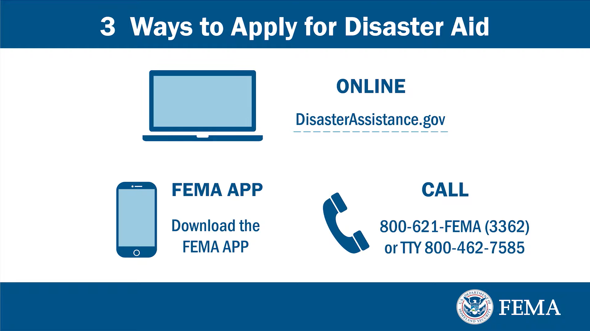
{[CompanyLongName]} is a debt collector attempting to collect a debt. Any information obtained will be used for that purpose. If your original obligation has been discharged or you have filed for protection under Title 11 of the United States Code and there is a valid stay in place, this notice is for compliance and/or informational purposes only.

{[L003]} (LETTER ID)/{[L005]} (LETTER SENDER ID)

